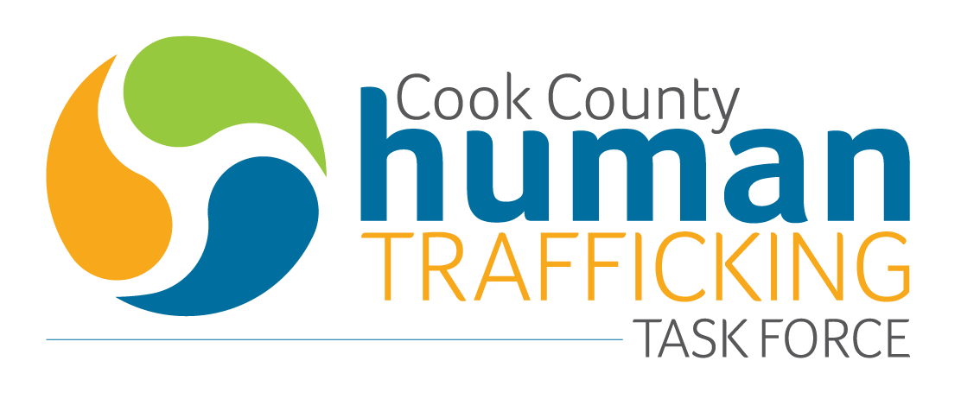
REQUEST FOR PROPOSAL

The Cook County Human Trafficking Task Force is a multi-disciplinary task force that brings law enforcement, social service, and legal service agencies together to address human trafficking.
Each year, the Task Force hosts a human trafficking conference to inform, educate and strengthen anti-trafficking efforts in Cook County and the Northern District of IL. The conference generally features two full days of presentations on innovative work from local and national experts on human trafficking. This year, the conference will include an additional introductory afternoon for stakeholders newly engaged in anti-trafficking efforts who seek to build their skills and incorporate strategies for trauma-informed on-the-ground support for survivors of human trafficking into their work. The Ninth Annual Cook County Human Trafficking Conference will take place on August 7, 8 and 9, 2019 at IIT Chicago - Kent College of Law at 565 W. Adams, Chicago, IL.

To broaden the diversity of presenters and presentations, The Cook County Human Trafficking Task Force requests proposals for sessions at the 2019 annual conference that align with the following theme:

Trauma-Informed Strategies for Addressing Human Trafficking – Moving Past Buzz Words and into Multidisciplinary Practice.

The 2019 conference aims to: 1) explore trauma-informed models across sectors that strategically address the issue of human trafficking; 2) analyze new research to help quantify and qualify the nature and magnitude of human trafficking; 3) discuss promising prevention methods at systemic and community levels to address the root causes of human trafficking; 4) explore innovative local and national models that comprehensively respond to human trafficking using a multidisciplinary approach; and, 6) explore strategies by which the anti-trafficking movement can be more survivor-informed and prevent re-exploitation.

Proposal Topic Areas

**Every proposal must specifically use the lens of prevention, identification or response while exploring a particular topic or area of focus. This list is not exhaustive, but proposals in these topic areas are preferred.

- Survivor-Informed Programming
- Engaging Male Survivors of Sex and Labor Trafficking
- Effective Strategies: Engaging with LGBTQ Youth Participating in Survival Sex
- Traveling Sales Crews
- Gang-Involved Human Trafficking
- Systems Change: Improving Implementation of Policy to Improve Responses to Human Trafficking
- The Intersection of Labor Trafficking and Sexual Violence
- Broaching Intersectionality: Addressing Community Violence, Poverty, Racism and Inequality and links to Human Trafficking
- Legislative Advocacy: When Laws Help and Hurt Survivors
- Using a Public Health Model to Address Human Trafficking
- A Closer Look: The Benefits of Specialized Healthcare Clinics for Survivors of Human Trafficking
- Prevention Methods for Youth at Risk
- Addressing Human Trafficking in Schools: Curricula for Young People and/or Teachers
- Familial Labor Trafficking and People with Disabilities
- Multidisciplinary Approaches to Prevention, Identification and Response
- Innovative Outreach and Engagement Methods
- Key Policy Change and Advocacy from the Worker’s Rights Movement
- Trauma-Informed Promising Practices and Therapies
- Ethical Marketing: The Fine Line between Awareness and Re-Exploitation
- The Impact of Public Awareness Campaigns on Identification
- Technology and Human Trafficking - Using Big Data to Prevent, Identify and Respond
- Bringing Corporations to the Table: Innovative Ways to Engage the Business Community to Enhance Service Provision
- Effective Trauma-Informed Law Enforcement Strategies
- Preventing Re-Victimization: A How To For Various Professionals
- Ritual Abuse and Human Trafficking
- Lessons Learned: Case Study involving a Multidisciplinary Team
- Victim Intimidation and Tampering
- Self-Care: Approaches to Sustainable Staffing in the Midst of Hard Work
- Financial Footprints: Anti-Money Laundering Efforts in the Fight Against Human Trafficking
- Online Recruitment in the Age of Social Media
- Building Trauma-Informed Spaces from Start to Finish

Proposal and Evaluation Criteria

Proposals are due by March 30, 2019.

Applicants will submit a one to two-page proposal using the provided template (12 point font, double spaced) that addresses the following:
- Proposed presenter(s)
- Type of proposed presentation
  - Seminar – An educational presentation given in a lecture-style format.
  - Panel - A small group of experts present a wide range of perspectives on one specific topic led by a moderator. This can be structured in the form of a roundtable as well.
  - Workshop – An intensive discussion and activity on a particular subject or project. These presentations should be interactive and can include small group breakouts.
  - Caucus –A time for affinity groups or people working on similar projects to gather and exchange ideas, network and build community.
- Session skill level
  - Fundamentals – basic for new staff, professionals, volunteers, or community members looking to get involved (0-1 year of experience in topic area)
  - Intermediate – content includes putting theory into practice, practical application, challenges, barriers and problem solving. (2-5 years of experience in topic area)
  - Advanced – sessions tailored for anti-trafficking experts with seasoned knowledge of context, issues and promising practices. Can include case studies and high-level problem solving. (5+ years of experience)
  - All Audiences – session is suitable for participants of all skill levels.
- Proposed subject matter (please indicate if proposing a ‘Law Enforcement Only’ session)
- Value of proposed presentation and impact on field
- Relevance to task force goals
- Qualifications of presenter (short paragraph of bio, details provided in CV)

Proposals must be submitted in PDF electronic format using the template on page 5 and 6 to the Salvation Army STOP-IT Program at stop-it@usc.salvationarmy.org by midnight on March 30, 2019.

The Cook County Human Trafficking Task Force Conference Planning Committee will evaluate the proposals. The following are the merit-based criteria for evaluation: relevance to anti-trafficking community at large (25%); alignment with task force goals, mission and guiding principles (25%); innovation or value added to the national discussion on human trafficking (25%); trauma-informed and victim-centered approach (15%), and qualifications and expertise of proposed presenters (10%). Chosen presenters will be notified by the middle of May 2019.
Please note that all presentations must be trauma-informed, must respect the privacy of survivors, must protect confidentiality, and must strategically change any names or redact identifying information when referencing specific cases. Presentations should not utilize stereotypical imagery or perpetuate extreme narratives of human trafficking. Any presentations that are not aligned with these standards will not be considered for the conference.

FAQs

Q: When is this proposal due?
A: The proposal is due by midnight CST on March 30, 2019
Q: When will presenters be announced?
A: Presenters will be announced in May 2019
Q: Where will I submit my final proposal?
A: Proposals should only include pages 5 and 6 of this document, which is a template for your application. PDFs of this information should be sent to stop-it@usc.salvationarmy.org.
Q: When and where will the conference take place?
A: The conference will take place at IIT Chicago - Kent College of Law on August 7, 8, and 9 2019. IIT Chicago - Kent College of Law is located at 565 W. Adams, Chicago, IL.

NAME AND AFFILIATION:
Presenter: Click here to enter name
Phone: | Click here to enter phone number
Email: | Click here to enter email address.
Other Presenters(s): |  |  | Click here to enter name(s).
TITLE OF PROPOSED PRESENTATION:
Click here to enter title.
DESCRIPTION OF PRESENTATION
Please provide a brief description for the presentation that you are proposing. Co-presenters should discuss and agree on the session title and description before submitting this information.

Please make sure to include the following: 1) the type of presentation you are proposing (seminar/panel/workshop/caucus); 2) the skill level of the session (fundamentals/intermediate/advanced/all audiences); 3) whether you are addressing prevention, identification, or response; and, 4) the target audience for your presentation.
Click here to enter comment.

HAVE YOU GIVEN THIS PRESENTATION BEFORE? IF SO, WHEN AND WHERE?

If you have, please include a version of presentation slides that were utilized in the past, or any video or links that are related to the presentation.
Click here to enter comment.
DOES YOUR PRESENTATION INCLUDE RESEARCH? IF SO, HAS IT BEEN PUBLISHED? WHERE?
Click here to enter comment.

RELEVANCE TO TASK FORCE GOALS
Please describe how this presentation aligns with key task force goals, including enhanced collaboration among law enforcement, social service providers, and other first responders, victim-centered service provision and prosecution, and specifically, the goals identified for the 2019 conference (listed above).
Click here to enter comment.
VALUE TO LOCAL/NATIONAL DISCUSSION ON HUMAN TRAFFICKING
Please describe how this presentation will add value to the local and national discussion around human trafficking.
Click here to enter comment.
QUALIFICATIONS OF PRESENTER(s)
Please briefly describe the presenter’s current employment/assignment and professional responsibilities/activities that directly relate to human trafficking, specific areas of expertise, and a general professional history. Additional details may be attached in a CV with this proposal.
Click here to enter comment.

